Student’s Name
Professor
Course
Date
Emotional Intelligence test
The emotion intelligence test is a fair and specific ability that relates to how individuals understand and manage their own emotions and those of the people around them (Magrum et al. 107). Employers and many other organizations use these tests to know which employees can possess the best relationship handling skills based on their scores. Low scores connect to poor relations, while higher scores indicate higher abilities to relate better. The various elements used in this testing include emotional regulation, expression, reflection, adaptability to social skills, empathy, and goal setting. Having managed to sincerely answer all the questions presented in the emotional tests in this assignment, the screenshots below reveal my score.

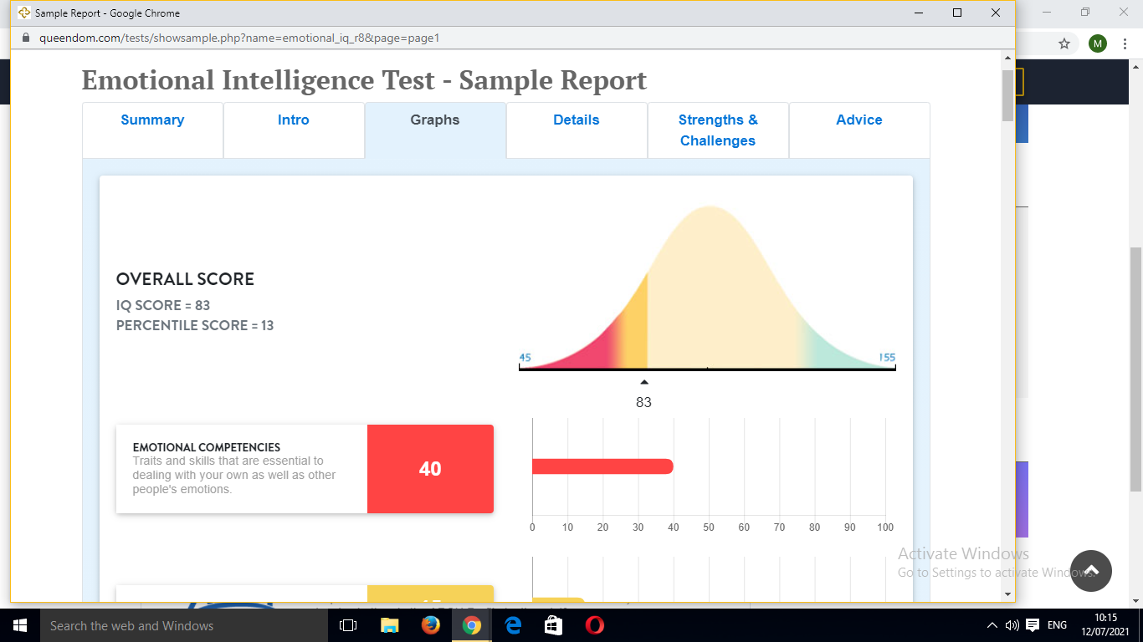

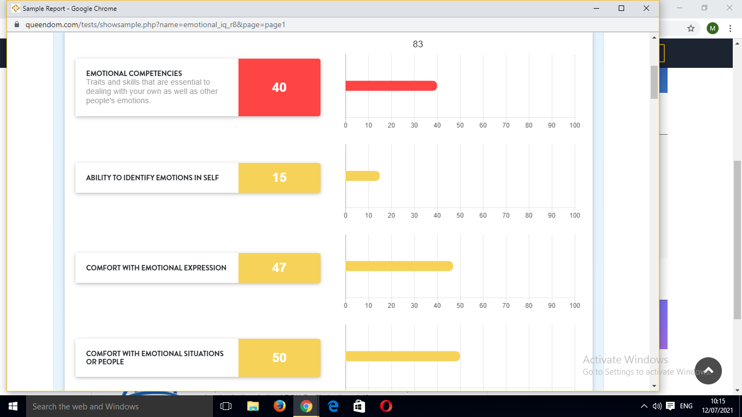
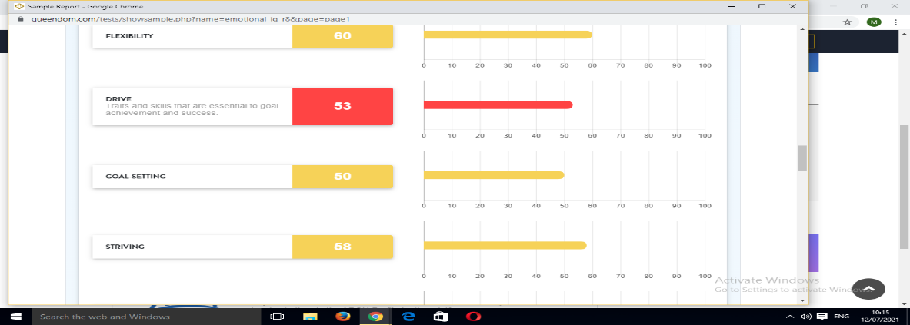
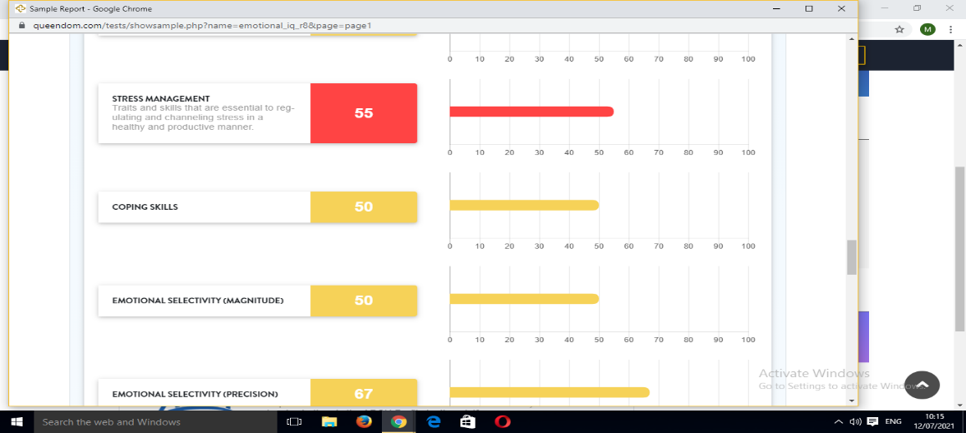

Despite delivering satisfactory results on how good I am at reading my emotions and those of others, an overall score of 83 on IQ and 13 on percentile rating, I feel not fully contented on the overall score depending on how I high-rated my emotions-reading ability prior to the test. However, since there exist various dimensions that are considered in having the overall score, I am happy that I scored higher in some. On emotional selectivity, I scored highest with a 67 score in the range of 0-100. Most of my daily life, which I partly spend as an adult counselor, leads me to experience and reading others' feelings. I get to understand their life challenges get into searching for the most suitable solutions. On this note, I am somehow to realize that the "empathy" dimension, which is one and the same to the counseling career, I scored 61, making it the second-best score on the dimensions of the emotional test. The flexibility ability became third with a 61 test score. Surprisingly, despite having the ability to identify with other people's emotions, I scored lowest when it came to identifying with my own emotions, having a 15 score rating. This score is poor in relation to the rest of the dimensions used.
Emotional intelligence capabilities change over time. They can be improved or made poor after a considerable duration of time, as noted by Gong et al. 198. Nonetheless, since many people strive to create stronger relationships with their neighbors, they can only work on improving their emotional reading abilities. Some of the strategies that I will apply to increase my emotion comprehending skills include an increased observance of how people react to different situations. People never behave the same even if they found themselves in a similar situation (Gong et al., 198). I will employ the strategy of putting myself in their positions to open and usher more acceptance to their needs and perspective. I will take enough time to divulge all the facts that will give me a fair judgment on people's emotions. The second plan that I will use is doing a consistent self-evaluation to check my strengths and weaknesses. This will greatly improve my emotional intelligence since I will possess a higher level of self-discovery. The last method that I will incorporate is taking enough responsibility for my various actions. In case I perform a hurting experience to someone, I will not waste my time ignoring the person. I will be seeking forgiveness directly to create a healthy relationship between the people and my surrounding. People are willing to forgive and forget when the apology is made honestly (Johnson et al., 30). If people are more forgiving and accommodating, why should do I not seek that forgiveness?

Work Cited
Gong, Zhun, Yuqi Chen, and Yayu Wang. "The influence of emotional intelligence on job burnout and job performance: Mediating effect of psychological capital." Frontiers in Psychology 10 (2019): 2707.
Johnson, Andre E., and Earle J. Fisher. "But, I Forgive You?": Mother Emanuel, Black Pain and the Rhetoric of Forgiveness." Journal of Communication & Religion 42.1 (2019).
Magrum, Eric D., et al. "Emotional intelligence in sport: a ten-year review (2008-2018)." International Journal of Coaching Science 13.2 (2019). 100-110

